Premraj Prakare Python Test7

class Book:

def __init__(self, bid, name, price, author):

self.bid = bid

self.name = name

self.price = price

self.author = author

def add_book(books):

bid = int(input("Enter book ID: "))

name = input("Enter book name: ")

price = float(input("Enter book price: "))

author = input("Enter author name: ")

books[bid] = Book(bid, name, price, author)

print("Book added successfully!")

def delete_book(books):

bid = int(input("Enter book ID to delete: "))

if bid in books:

del books[bid]

print("Book deleted successfully!")

else:

print("Book not found")

def display_books(books):

if not books:

print("No books in the database.")

else:

for book in books.values():

print(f"ID: {book.bid}, Name: {book.name}, Price: {book.price}, Author: {book.author}")

def search_book(books):

bid = int(input("Enter book ID to search: "))

if bid in books:

book = books[bid]

print(f"ID: {book.bid}, Name: {book.name}, Price: {book.book.price}, Author: {book.author}")

else:

print("Book not found")

def main():

books = {} # Dictionary to store book objects

while True:

print("\nMenu:")

print("a. Add Book")

print("b. Delete book by id")

print("c. Display all books")

print("d. Search book by id")

print("e. Exit")

choice = input("Enter your choice: ").lower()

if choice == "a":

add_book(books)

elif choice == "b":

delete_book(books)

elif choice == "c":

display_books(books)

elif choice == "d":

search_book(books)

elif choice == "e":

break

else:

print("Invalid input")

if __name__ == "__main__":

main()
output:
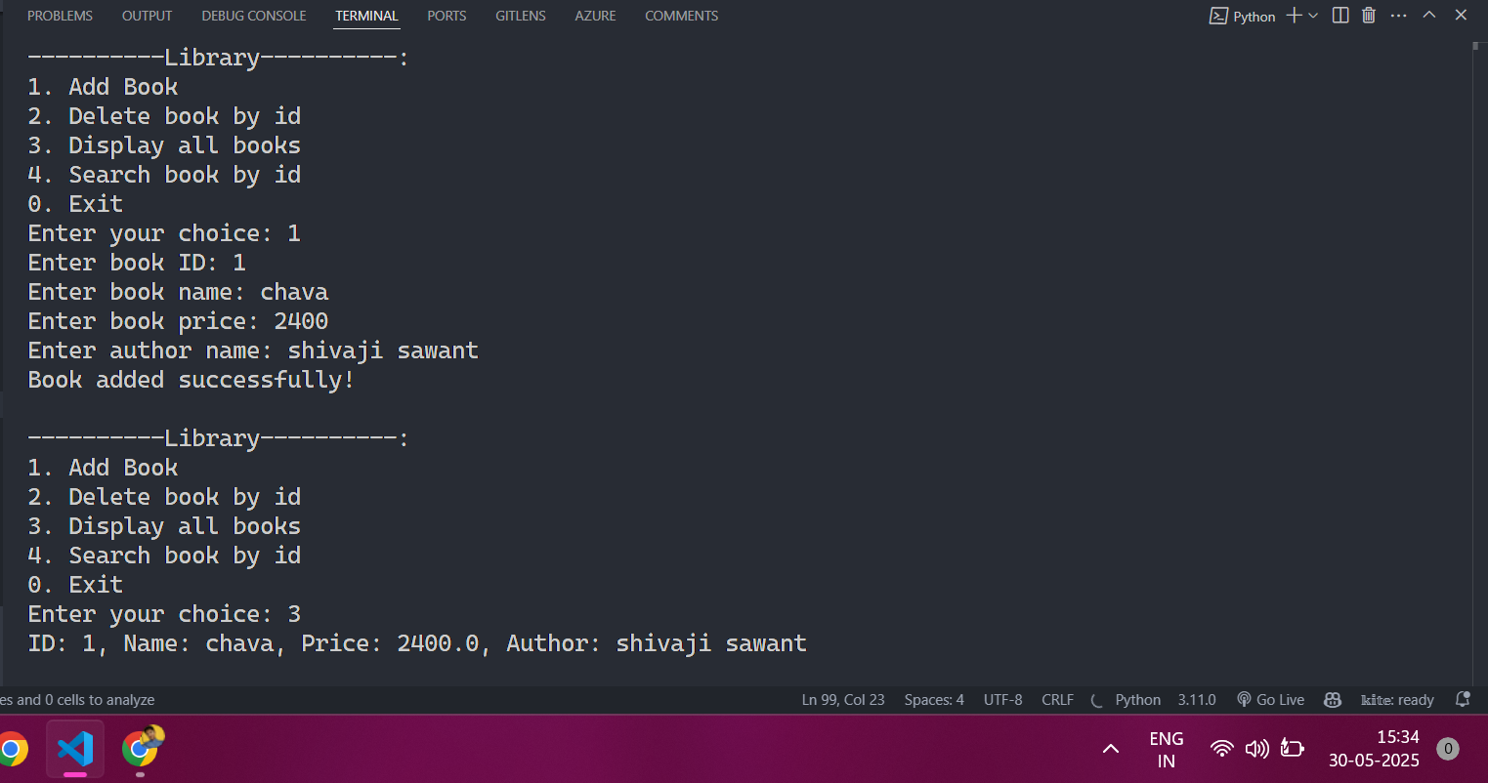

# q2
list1 = ["this","is","variable","list","comprehension"]
list2 = [ x.upper() for x in list1 ]
print("Original list :",list1)
print("Uppercase list :",list2)
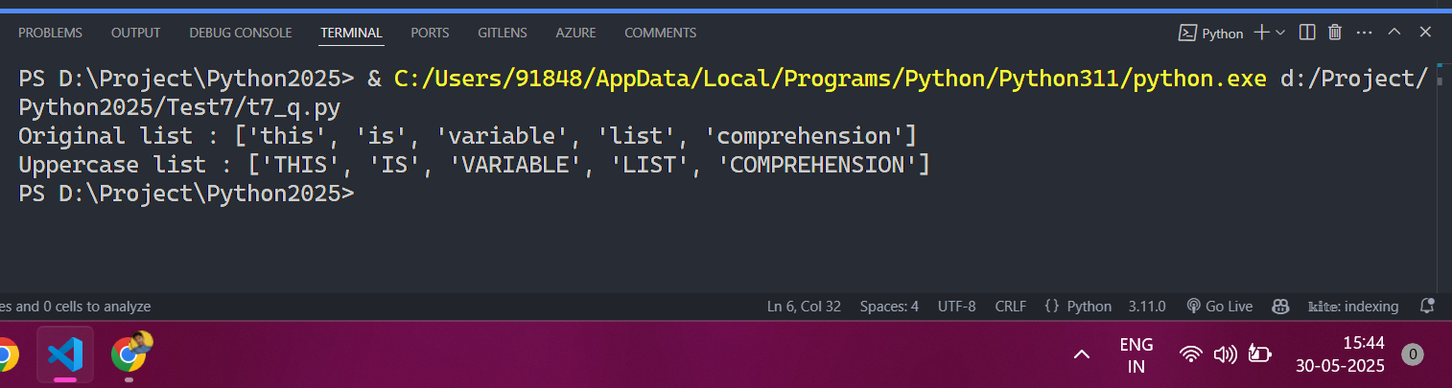

# q3
list1 = [x for x in range(1,51) if x % 2 == 0]
print("Even numbers from 1 to 50:", list1)
output:
